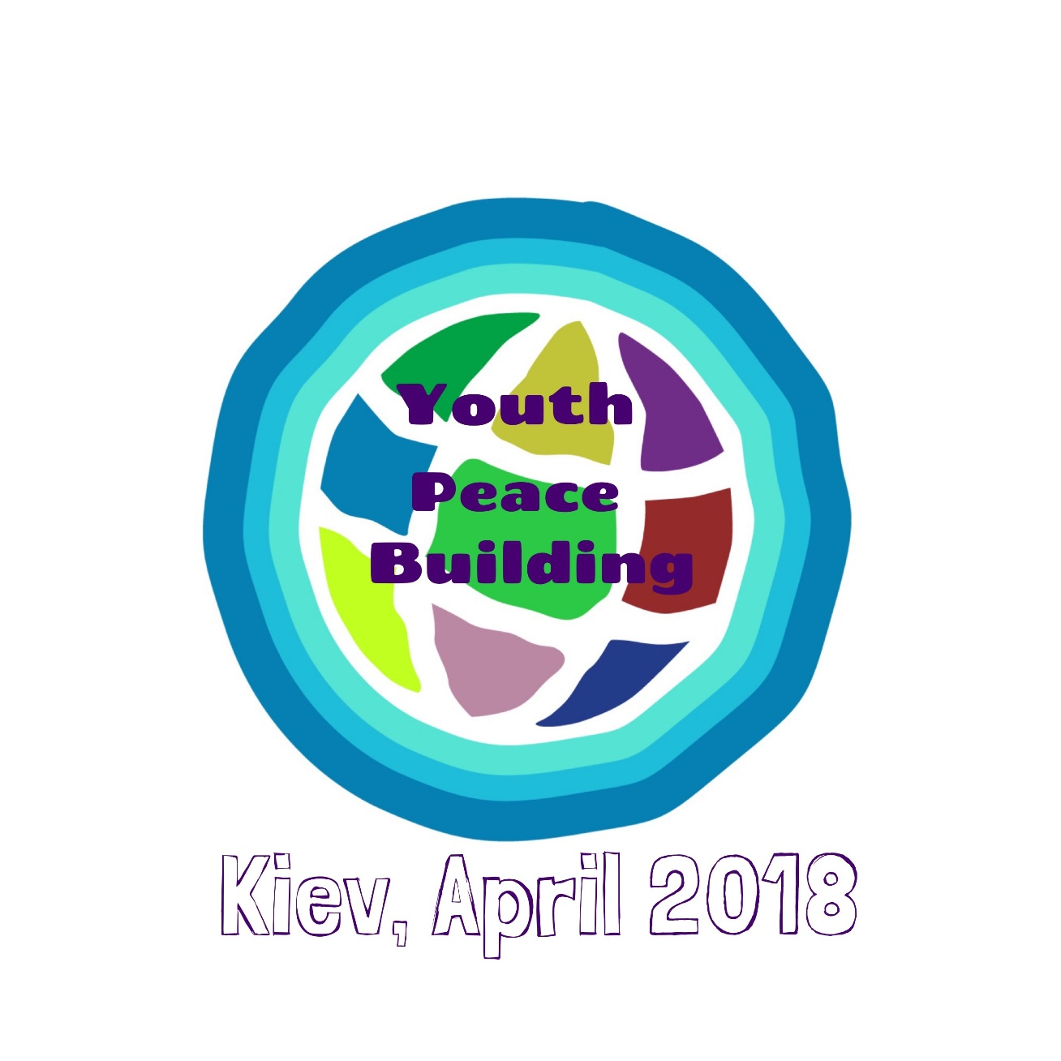
APPLICATION FORM

Please fill in the following questionnaire if you want to take part in the Training Course

“Youth Peace Building”
Kiev, April 20-29 2018

The training will give the opportunities to young activists and young leaders to acquire useful theoretical and practical skills to set up a peacebuilding discourse in their communities as well as establish durable and useful relations with the other participants as future partners for their personal initiatives.
The training course is sponsored through the ERASMUS+ EU program
As there are limited places for this training ensure to send back this questionnaire as soon as possible (not later than March 30) to alliancedon@gmail.com and to Federicoslvt@gmail.com
Please understand that we will have to choose participants. You will get the information of your participation as soon as possible.
Full program, accommodation (shared rooms) and food are included for free. Your travel costs (cheapest means of transport) will be reimbursed after the course according to the rules and regulations of Erasmus + Program. Your full presence for the whole course is obligatory.
If you have questions best way is to send an email, or phone +49 163 140 1006

Personal data

Name: ______________ Family Name: ___________

Address: _________________________________________________________

Date of birth _______
Phone: _____________________ Email: ________________________________________

Special needs (e.g. vegetarian...):

Working language will be English, please tell us your language abilities:
 | Level: | fluent | good | medium | basic | poor
Working language | English
Second language

Your Organisation
Name: ______________________________________

Address ________________________________________________________________
Phone __________________________ email/website: _______________________

are you working there: as a Volunteer: or professional:

Please describe shortly the work of your organisation:

Describe your personal experience in youth work in a few words (what kind of young people you are working with, what methodical approaches you have and what practical activities you set)

If you have experience on an international level of youth work please describe it

What is your experience in peacebuilding or peace related activities?

What is your motivation for attending this training:

What do you expect from this training course:

Anything else you want to add:

